FL-WEEK 1: DRAW THE PATH
Portfolio Sitemap + Toolkit
Name: Jiya Yadav
Track: General AI Fluency
Week: 1
Live Portfolio: https://jiya-ydv.github.io/jiya-yadav.github.io/

SECTION 1: My Claim + My One Action
My Claim (Proof Statement):
"AI/ML Engineer with hands-on experience building end-to-end production ML systems. Built and deployed a multi-agent AI platform, fine-tuned transformer models, achieving 0.89 macro F1 on emotion classification, and established CI/CD pipelines with 74% test coverage. MSc Information Technology (AI/ML) graduate (results awaited). Passionate about building transparent, reliable, and production-ready AI systems."
My One Action:
Get the visitor to view my featured project — the Mental Health Agentic AI Platform live demo — and then contact me for AI/ML engineering roles.

SECTION 2 — Portfolio Sitemap Sketch
Below is my sketched portfolio sitemap, showing the visitor journey from Landing → Proof → One Action.
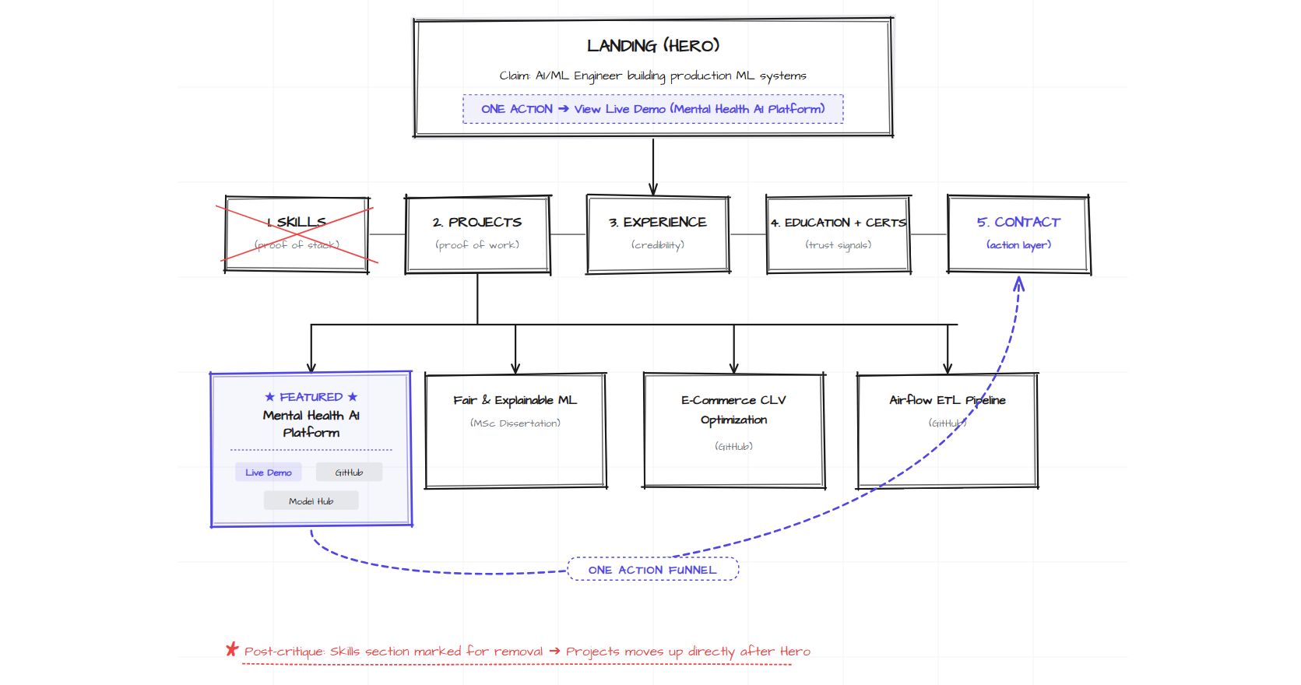
Live portfolio: https://jiya-ydv.github.io/jiya-yadav.github.io/

SECTION 3 — Sitemap Explanation
Why Each Section Earns Its Place:
Section | Purpose | Why It Earns Its Place
Hero (Landing) | State the claim | Sets identity and drives the first action (Live Demo CTA)
Projects | Prove the work | The featured project (Mental Health AI) is the strongest evidence of the claim
Experience | Add credibility | Shows real work history (FlyRank AI)
Education + Certs | Trust signal | MSc IT (AI/ML) confirms qualification
Contact | The ONE action endpoint | Email, LinkedIn, GitHub, HF — closes the funnel
Skills | Proof of stack | Cut post-critique — redundant with project stack chips

Every remaining section funnels the visitor toward: read claim → see featured project proof → make contact.

SECTION 4 — Claude Project Screenshot
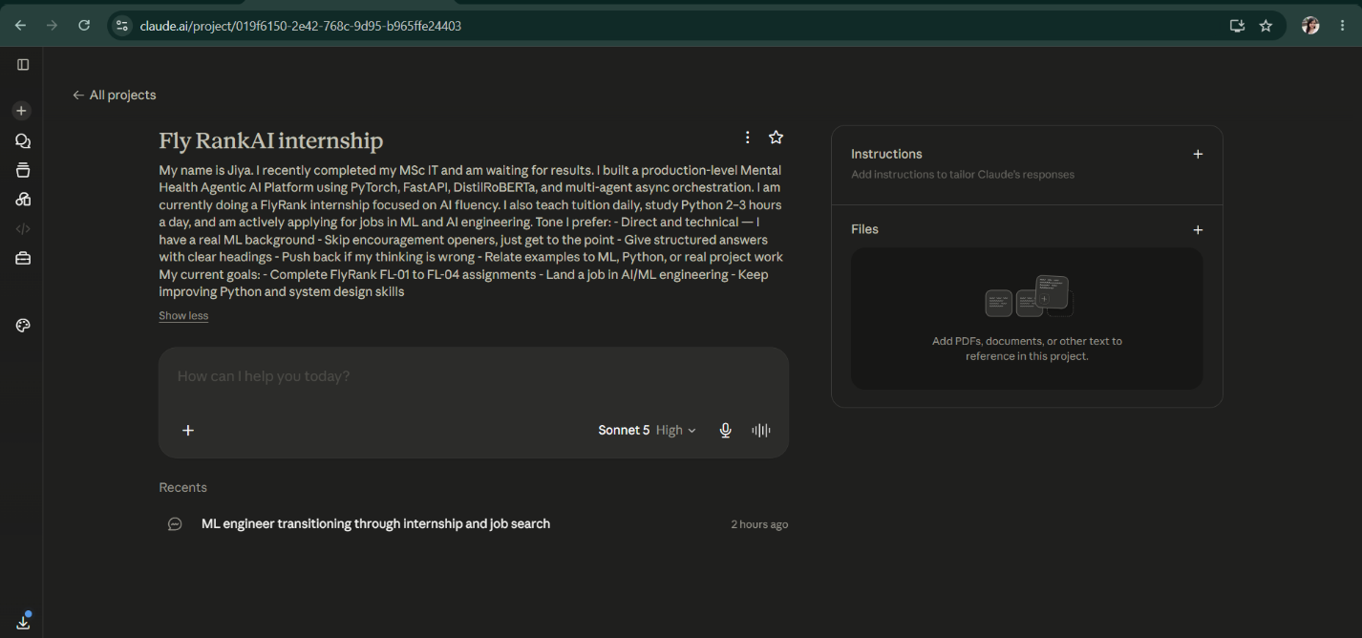
I created a dedicated Claude Project named "Fly RankAI internship" with custom instructions containing my proof statement, background context, tone preferences, and a request to act as a technical tutor. This project follows me for all 8 weeks of the FlyRank track.

SECTION 5: Pressure-Test Prompt Sent to Claude
I am pressure-testing my portfolio site for the FlyRank Draw the Path assignment.
LIVE PORTFOLIO: https://jiya-ydv.github.io/jiya-yadav.github.io/
MY CLAIM:
"AI/ML Engineer with hands-on experience building end-to-end production ML systems. Built and deployed a multi-agent AI platform, fine-tuned transformer models, achieving 0.89 macro F1 on emotion classification, and established CI/CD pipelines with 74% test coverage. MSc Information Technology (AI/ML) graduate (results awaited). Passionate about building transparent, reliable, and production-ready AI systems."
MY ONE ACTION:
"Get the visitor to view my featured project — the Mental Health Agentic AI Platform live demo — and then contact me for AI/ML engineering roles."
MY CURRENT SITEMAP (single-page site with these sections):
1. HERO — states the claim, shows CTAs: View Live Demo, GitHub, Email
2. SKILLS — 6 categories: ML, Programming, ML Engineering, MLOps, Data, Cloud
3. PROJECTS — Featured (Mental Health AI) + 3 supporting (Fair ML, E-Commerce, ETL)
4. EXPERIENCE — FlyRank + GCG International
5. EDUCATION — MSc IT + BSc Computing + Certifications
6. CONTACT — Email, GitHub, LinkedIn, Hugging Face, phone, form
PRESSURE-TEST THIS SITEMAP. Be direct and technical:
1. Does every section earn its place against my claim and my one action?
2. Is the funnel from Hero → Featured Project → Contact clear enough, or is it diluted by too many competing CTAs?
3. Is anything missing that a hiring manager or ML recruiter would need to make a decision?
4. Is anything on the site actively working against my claim?
5. What is the single weakest link in the visitor journey?
6. If you had to cut ONE section entirely, which would it be and why?
Do not be polite. Tell me what to cut, what to strengthen, and what to reorder. Give reasoning before conclusions.

SECTION 6 — Claude's Full Response
I pulled the live site directly rather than working from your sitemap description, so this critique is against what's actually deployed. One thing jumped out before I even got to your six questions: your hero tagline "Aspiring AI/ML Engineer" sits directly under your name, and the paragraph beneath it claims you're already building production systems. That's a self-inflicted contradiction on the first screen. Fix that regardless of anything else below.
1. Does every section earn its place?
Hero — Yes, mostly. The stat bar (0.89 F1 / 74% coverage / 40% latency / 4+ projects) is the right move — quantified proof above the fold is rare and effective. But "Aspiring" directly under-cuts the claim one line below it. That word is doing the opposite of its job.
Skills — Weak justification for a standalone section. It's a tag dump across 6 categories, and every one of those tags already reappears under the relevant project as a stack chip. A dedicated Skills section only earns its place if it's telling the recruiter something the projects don't. Right now it's pure repetition with extra scroll distance before they reach the one thing you want them to click.
Projects — Featured project earns its place completely: problem framing, quantified bullets, three working outbound links (Demo/Source/Model). This is the strongest section on the site.
The three supporting projects don't earn equal weight, though. Fair & Explainable ML — arguably your most rigorous piece of work (fairness + 4-method explainability stack) — has no outbound link at all. No GitHub, no writeup, nothing. A claim with no receipt is worse than not making the claim, because it trains the recruiter to start discounting your other bullets too, including the verified ones.
Experience — Earns its place structurally (recruiters need work history) but underperforms on content. FlyRank is dated Jul 2026–Present, which is today — meaning this is a brand-new role and the vague bullet ("contributing to model integration and API design") is probably vague because there's genuinely nothing shipped yet to quantify. That's understandable, but it's still the least specific paragraph on the page. GCG International is a digital marketing analyst role with zero ML content, sitting under "Work Experience" right next to your AI internship. It doesn't support the claim — it dilutes the identity you're building.
Education — Necessary, but "Results Awaited" is an open loop next to a present-tense "AI/ML Engineer" claim. Not fatal, but it needs framing, not just a status label.
Certifications — This is actively working against you and I'll cover it in Q4.
Contact — Necessary as an endpoint, over-built as a menu. Five channels plus a form is not "easy to reach me," it's "pick your own adventure."
2. Is the funnel diluted?
Count the exits on this single page: 3 in the hero, 3 on the featured project, 1–2 each on the three supporting projects, then 5 contact channels + a form. That's somewhere around 13–14 distinct outbound click targets competing for attention on a page whose stated one action is "view demo → contact."
The structural problem isn't that these links exist — a recruiter does need GitHub and LinkedIn eventually. The problem is they're all presented with roughly equal narrative weight. There's no visual or sequential signal that says "this one path matters, everything else is secondary." A single-action funnel needs one dominant CTA and everything else visibly subordinate — smaller, later, or grouped under "more ways to reach me." Right now, the page reads like six sections, each making their own pitch, not one page making one pitch six times.
3. What's missing that a hiring manager actually needs?

No resume/CV download. This is a real gap. Recruiters forward PDFs internally; a live site link doesn't survive an ATS or an internal Slack thread the way a resume does. Add a "Download Resume" CTA near the hero, not buried in Contact.
No proof link for the Fair ML dissertation — covered above, but worth repeating because it's disqualifying-by-omission for a technical reviewer who wants to verify before believing.
No availability/notice period. You're currently in an active internship — a recruiter reading this doesn't know if you're job-searching casually, ending soon, or open to conversations now. Ambiguity here costs you outreach.
No visa/work-authorization signal beyond "open to remote & relocation worldwide." For a Nepal-based candidate targeting international roles, this is often the first filter a recruiter applies. Vague optimism here reads as unaddressed rather than flexible.
4. What's actively working against the claim?
In order of damage:
"Aspiring AI/ML Engineer" contradicts the confident claim one line below it.
The unlinked Fair ML project — an unverifiable claim sitting next to verified ones.
Certifications section — "SQL for Data Analytics: Zero to Hero — Udemy" and a Hugging Face fundamentals course, listed at the bottom of a page that opens with fine-tuned transformers and 0.89 macro F1. These read as beginner artifacts. They don't add credibility to someone claiming production ML engineering — they subtract from it, because they recalibrate the reader's sense of your level downward right before Contact. If you keep them, they need to be visually minor, not a headlined subsection.
GCG International in Work Experience — an unrelated marketing analyst role diluting an AI/ML professional identity. Either cut it or reframe the one sentence around a transferable skill (quantitative KPI analysis) instead of listing it as generic marketing work.
"Results Awaited" — not wrong to disclose, but currently unframed. "Completed — Results Awaited" reads like an open question. "Expected [month/year]" or similar reads like a timeline, not a gap.
5. Single weakest link in the journey
Experience, not Skills or Certifications, even though those have obvious problems too.
Reasoning: hiring managers weigh paid work history differently than personal projects, because it implies third-party validation — someone hired you, reviewed your output, paid you to keep doing it. Your Featured Project section is genuinely strong and does a lot of trust-building work. But right after that high point, the visitor hits two lines about a brand-new internship with no metrics, followed immediately by an unrelated marketing job. The trust curve goes up sharply through Projects and then flattens or dips through Experience — right before Contact, which is the worst place for it to happen. The section that should be reinforcing "this person performs in real jobs" is currently the thinnest, least specific part of the site.
6. If you cut one section entirely
Cut Skills.
Reasoning: Every tag in that section already appears as a stack chip under the relevant project. It's the only section on the page that adds zero new information — it's pure restatement, at the cost of an entire scroll segment between your claim (Hero) and your proof (Projects). For an early-career candidate with four projects, a recruiter forms their skill impression from what those projects actually used, not from a separate taxonomy slide. Cutting it shortens the path from claim to evidence, which is exactly what your one-action goal needs.
If you want to keep some trace of it, fold the category labels only (ML / MLOps / Cloud) into a single inline line in the hero or footer — not a dedicated section with its own scroll stop.
Net changes, ranked by effort-to-impact
Cut: Skills section (redundant with project tags). Reorder Projects to come immediately after Hero.
Fix now, low effort: Remove "Aspiring," reframe "Results Awaited," link the Fair ML dissertation to something — even a PDF of the writeup satisfies the verification instinct.
Reframe: GCG entry (transferable skill framing or cut it), Certifications (de-emphasize visually, don't headline).
Add: Resume download CTA, availability/notice period, one line on work authorization.
Collapse: Contact channels down to one primary (email or form) with the rest as small secondary icons, not equal-weight buttons.
The site's core asset — the Featured Project — is genuinely well-built and is doing its job. The rest of the page just isn't getting out of its way yet.

SECTION 7 — What I Will Change
Claude's pressure test surfaced a contradiction I had not seen: my hero labels me an "Aspiring AI/ML Engineer" while the paragraph directly beneath claims I have already built production ML systems with quantified results. That single word undercuts my entire claim on the first screen, so removing "Aspiring" is my highest-priority fix.
The second change is structural: Claude flagged that my Skills section is pure repetition of tags that already appear as stack chips under each project, and it sits between my claim (Hero) and my proof (Projects) — lengthening the path to my one action. I will cut the standalone Skills section and let the project stack chips do that work, so the visitor moves from claim to proof to contact with fewer detours.
The third change targets my funnel: my current site has roughly 13–14 competing outbound links, which dilutes the "View Live Demo → Contact" path. I will make Live Demo the single dominant CTA in the hero, demote GitHub and Email to smaller secondary buttons, and collapse my contact section to one primary channel (email) with the rest as small icon links — so the one action is visually unmistakable.
Additional smaller fixes I will apply:
- Reframe "Results Awaited" as an expected month/year to close the open loop
- Reframe or remove the GCG International marketing entry so it stops diluting my AI/ML identity
- De-emphasize the Certifications section visually so beginner-level certs do not recalibrate my perceived level downward right before Contact
- Add a Resume/CV download CTA near the hero for recruiter workflows
Where I overrode Claude's feedback (and why):
Claude recommended adding a proof link to my Fair & Explainable ML dissertation. I am intentionally not doing this yet. The dissertation is unpublished, results are still awaited, and releasing the full paper publicly before formal publication risks plagiarism theft and could compromise future publication rights. Instead, I will add a short problem-and-methodology summary to the project card with a note stating "Full paper available on request post-publication." This maintains credibility without exposing the work. This is exactly the kind of contextual judgment where human decision-making must override AI suggestions — Claude did not have my academic constraints in view.

